 Cybersecurity
Penetration Test Report

I-Connect Solutions Inc.

Penetration Test Report

Confidentiality Statement

This document contains confidential and privileged information from I-Connect Solutions Inc. Inc. (henceforth known as I-Connect Solutions Inc.). The information contained in this document is confidential and may constitute inside or non-public information under international, federal, or state laws. Unauthorized forwarding, printing, copying, distribution, or use of such information is strictly prohibited and may be unlawful. If you are not the intended recipient, be aware that any disclosure, copying, or distribution of this document or its parts is prohibited.

Table of Contents

Confidentiality Statement 2
Contact Information 4
Document History 4
Introduction 5
Assessment Objective 5
Penetration Testing Methodology 6
Reconnaissance 6
Identification of Vulnerabilities and Services 6
Vulnerability Exploitation 6
Reporting 6
Scope 7
Executive Summary of Findings 8
Grading Methodology 8
Summary of Strengths 9
Summary of Weaknesses 9
Executive Summary Narrative 10
Summary Vulnerability Overview 13
Vulnerability Findings 14

Contact Information

Company Name | I-Connect Solutions Inc.
Contact Name | Frederick Parker
Contact Title | Penetration Tester

Document History

Version | Date | Author(s) | Comments
001 | 2/12/2025 | Frederick Parker

Introduction

In accordance with I-Connect Solutions Inc. policies, our organization conducts external and internal penetration tests of its networks and systems throughout the year. The purpose of this engagement was to assess the networks and systems’ security and identify potential security flaws by utilizing industry-accepted testing methodology and best practices.

For the testing, we focused on the following:

- Attempting to determine what system-level vulnerabilities could be discovered and exploited with no prior knowledge of the environment or notification to administrators.
- Attempting to exploit vulnerabilities found and access confidential information that may be stored on systems.
- Documenting and reporting on all findings.

All tests took into consideration the actual business processes implemented by the systems and their potential threats; therefore, the results of this assessment reflect a realistic picture of the actual exposure levels to online hackers. This document contains the results of that assessment.

Assessment Objective

The primary goal of this assessment was to provide an analysis of security flaws present inI-Connect Solutions Inc.’s web applications, networks, and systems. This assessment was conducted to identify exploitable vulnerabilities and provide actionable recommendations on how to remediate the vulnerabilities to provide a greater level of security for the environment.

We used our proven vulnerability testing methodology to assess all relevant web applications, networks, and systems in scope.

I-Connect Solution has outlined the following objectives:

Table 1: Defined Objectives

Objective
Find and exfiltrate any sensitive information within the domain.
Escalate privileges.
Compromise several machines.

Penetration Testing Methodology

Reconnaissance

We begin assessments by checking for any passive (open source) data that may assist the assessors with their tasks. If internal, the assessment team will perform active recon using tools such as Nmap and Bloodhound.

Identification of Vulnerabilities and Services

We use custom, private, and public tools such as Metasploit, hashcat, and Nmap to gain perspective of the network security from a hacker’s point of view. These methods provide I-Connect Solutions Inc. with an understanding of the risks that threaten its information, and also the strengths and weaknesses of the current controls protecting those systems. The results were achieved by mapping the network architecture, identifying hosts and services, enumerating network and system-level vulnerabilities, attempting to discover unexpected hosts within the environment, and eliminating false positives that might have arisen from scanning.

Vulnerability Exploitation

Our normal process is to both manually test each identified vulnerability and use automated tools to exploit these issues. Exploitation of vulnerability is defined as any action we perform that gives us unauthorized access to the system or the sensitive data.

Reporting

Once exploitation is completed and the assessors have completed their objectives, or have done everything possible within the allotted time, the assessment team writes the report, which is the final deliverable to the customer.

Scope

Prior to any assessment activities, I-Connect Solutions Inc. and the assessment team will identify targeted systems with a defined range or list of network IP addresses. The assessment team will work directly with the Rekall’s POC to determine which network ranges are in-scope for the scheduled assessment.

It is I-Connect Solutions Inc.’s responsibility to ensure that IP addresses identified as in-scope are controlled by I-Connect Solutions Inc. and are hosted in Rekall’s-owned facilities (i.e., are not hosted by an external organization). In-scope and excluded IP addresses and ranges are listed below.

Executive Summary of Findings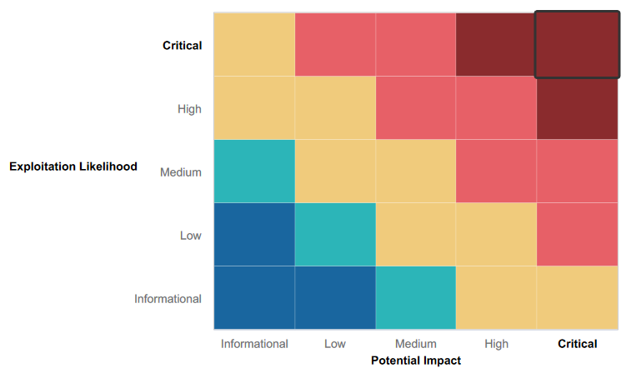

Grading Methodology

Each finding was classified according to its severity, reflecting the risk each such vulnerability may pose to the business processes implemented by the application, based on the following criteria:

Critical: Immediate threat to key business processes.
High: Indirect threat to key business processes/threat to secondary business processes.
Medium: Indirect or partial threat to business processes.
Low: No direct threat exists; vulnerability may be leveraged with other vulnerabilities.
Informational: No threat; however, it is data that may be used in a future attack.

As the following grid shows, each threat is assessed in terms of both its potential impact on the business and the likelihood of exploitation:

Summary of Strengths

While the assessment team was successful in finding several vulnerabilities, the team also recognized several strengths within Rekall’s environment. These positives highlight the effective countermeasures and defenses that successfully prevented, detected, or denied an attack technique or tactic from occurring.

- Proactive approach to mitigate vuns & attacks

Summary of Weaknesses

We successfully found several critical vulnerabilities that should be immediately addressed in order to prevent an adversary from compromising the network. These findings are not specific to a software version but are more general and systemic vulnerabilities.

- Weak Passwords Policies.
- Poor Patch Management
- Password Reuse
- Insecure Protocol
- Open ports
- SQL Injection
- Cross Site Scripting
- Privilege Escalation

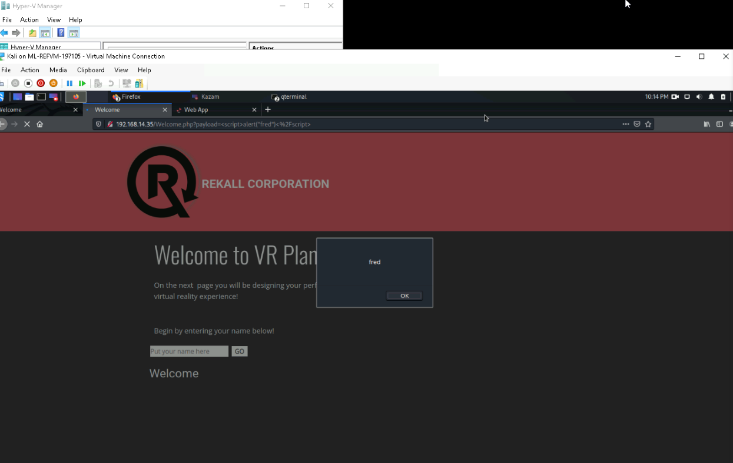

- Used xss scripting payload to bypass Input validation to gain access to web application
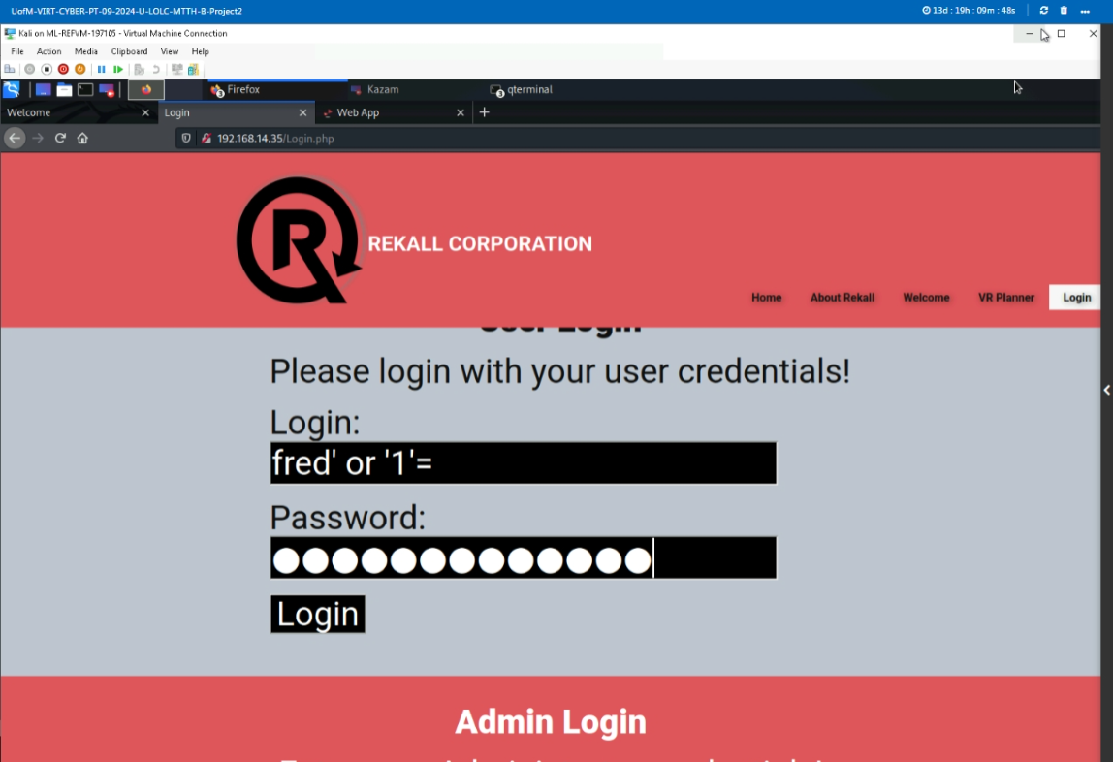

SQL injection allow entry to web app/database

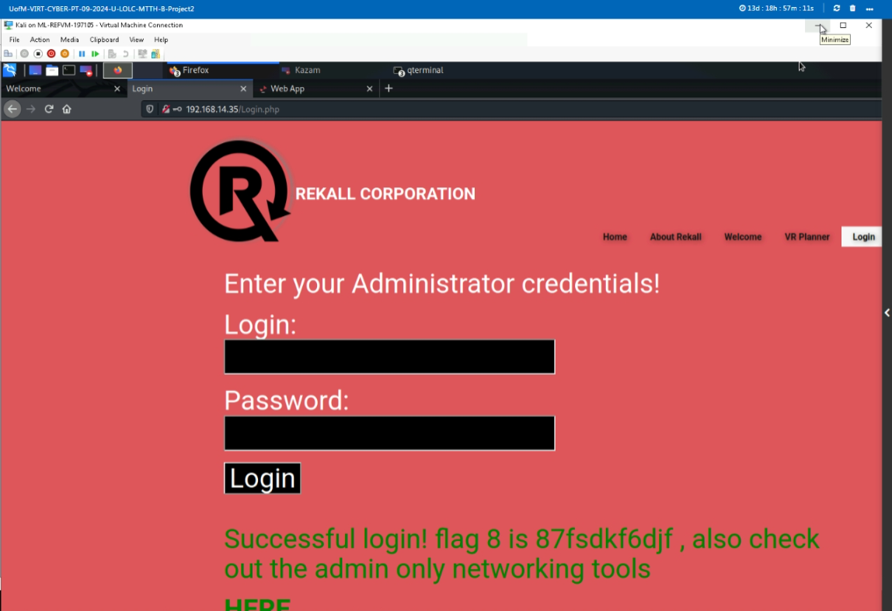

- Hijacked user credentials found in HTML code dougquaid:kuato Sensitive Data Exposue

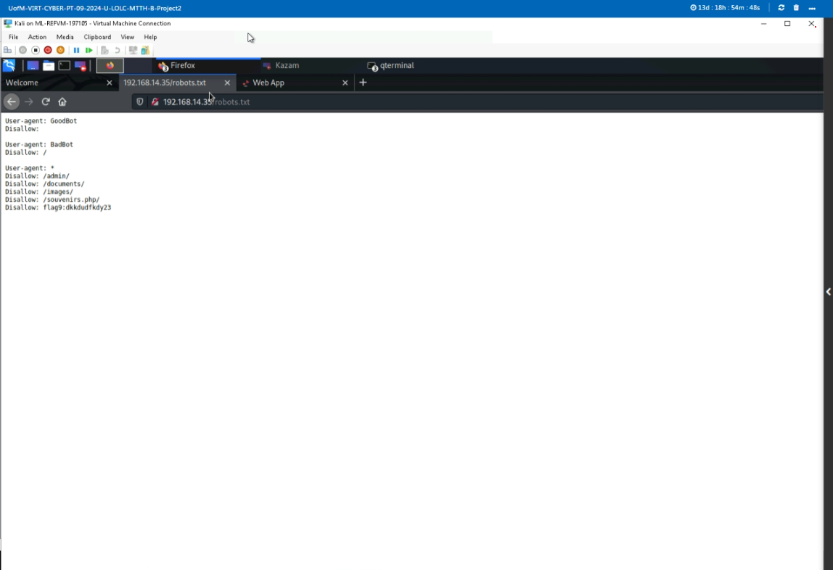

- Sensitive Data Exposure Robots.txt file

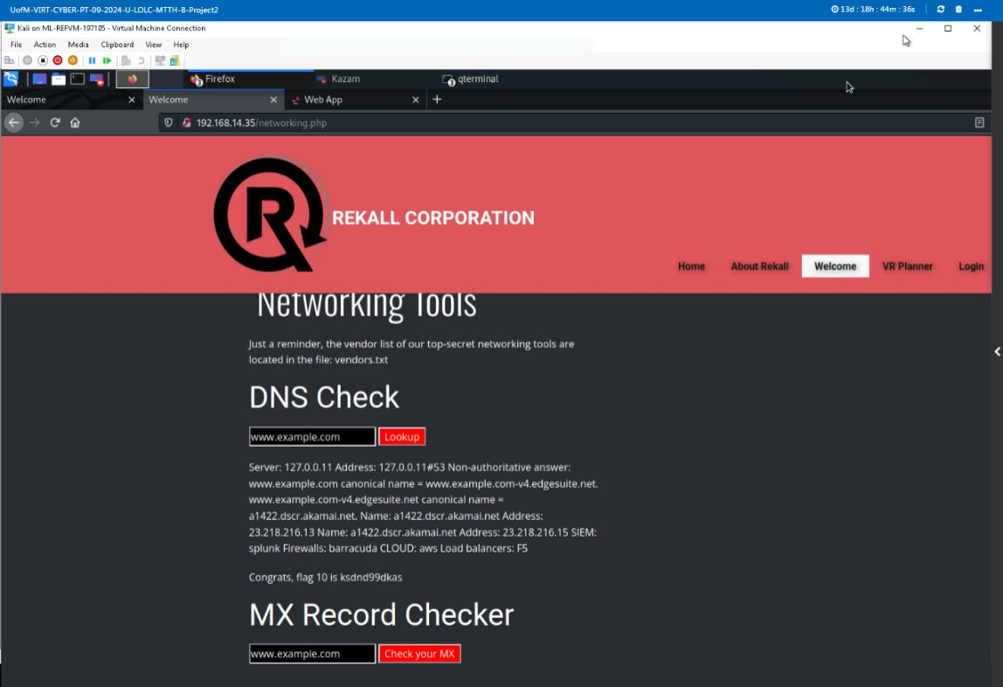

- Use Accessed the Network through command line injection exposure able to execute commands.

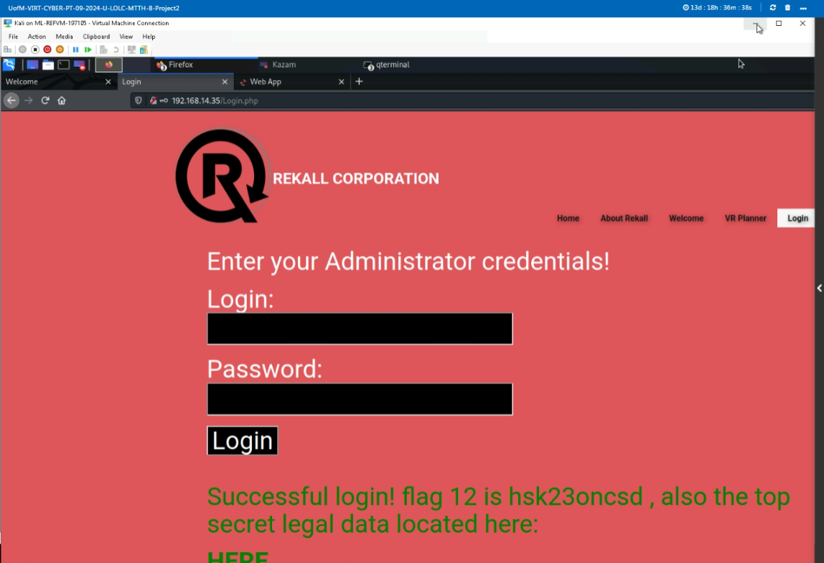

- Brute Force attack gain administrator access Melina:Melina

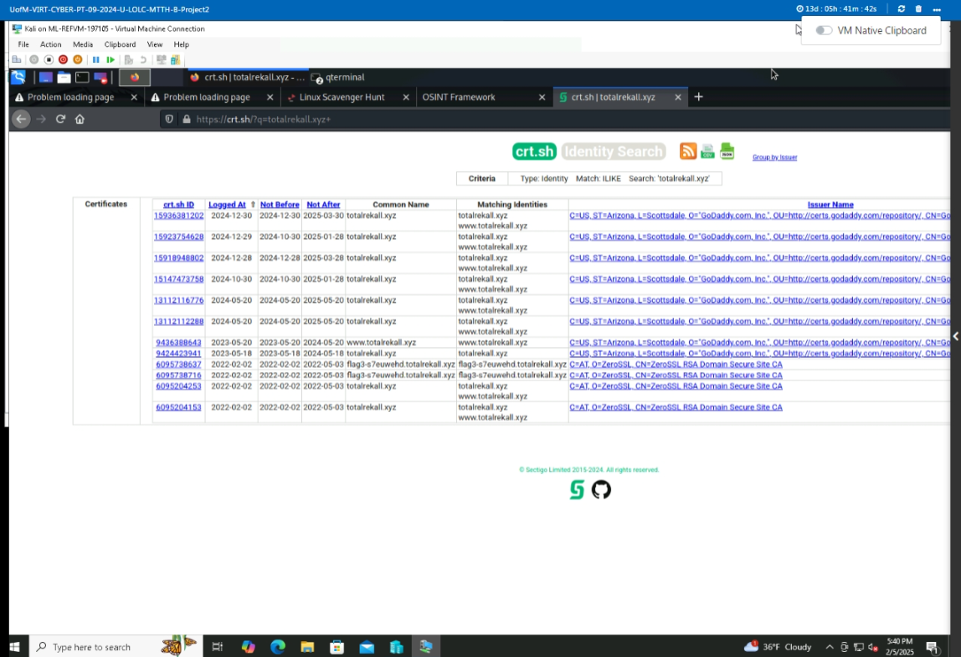

- Found SSL certificates

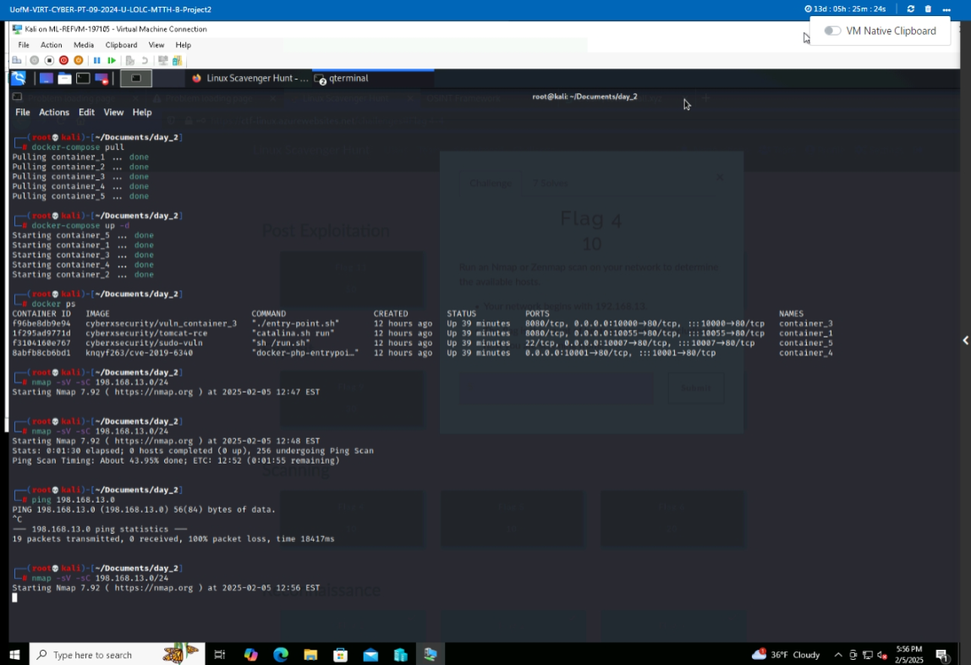

- Ran Nmap sV -sC scan 192.168.13.0/24 to find available host to exploit.

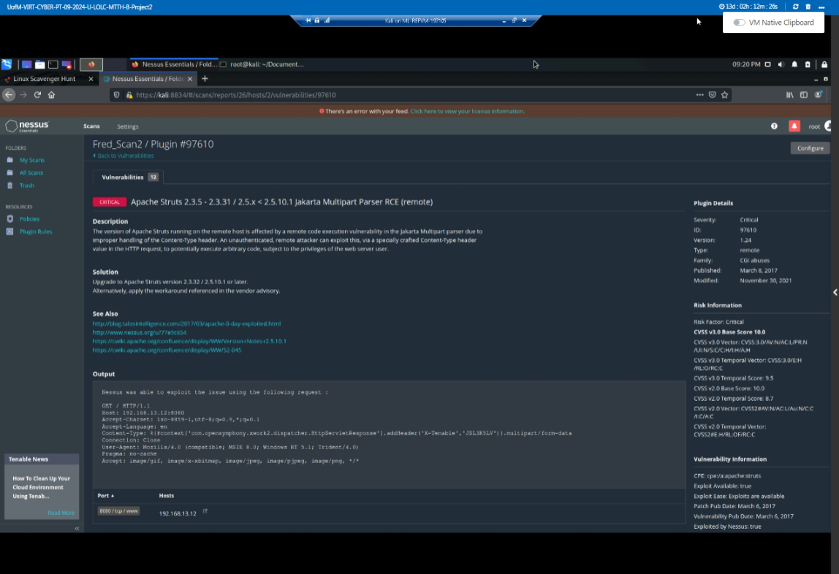

- Found Vuns for host 192.168.13.12 subject to RCE

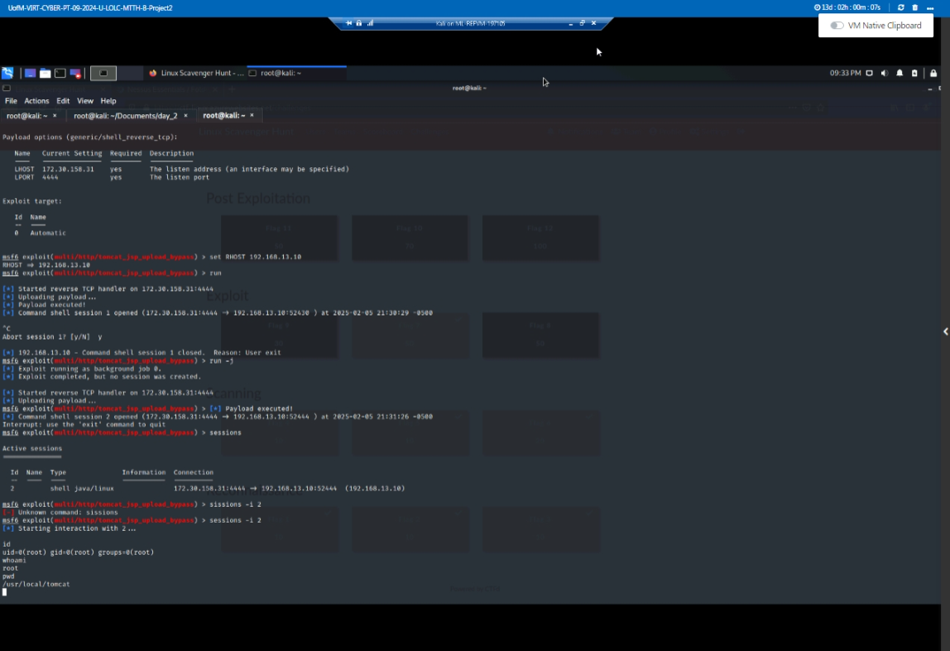

- Ran Metasploit to attack host 192.168.13.10 (RCE)

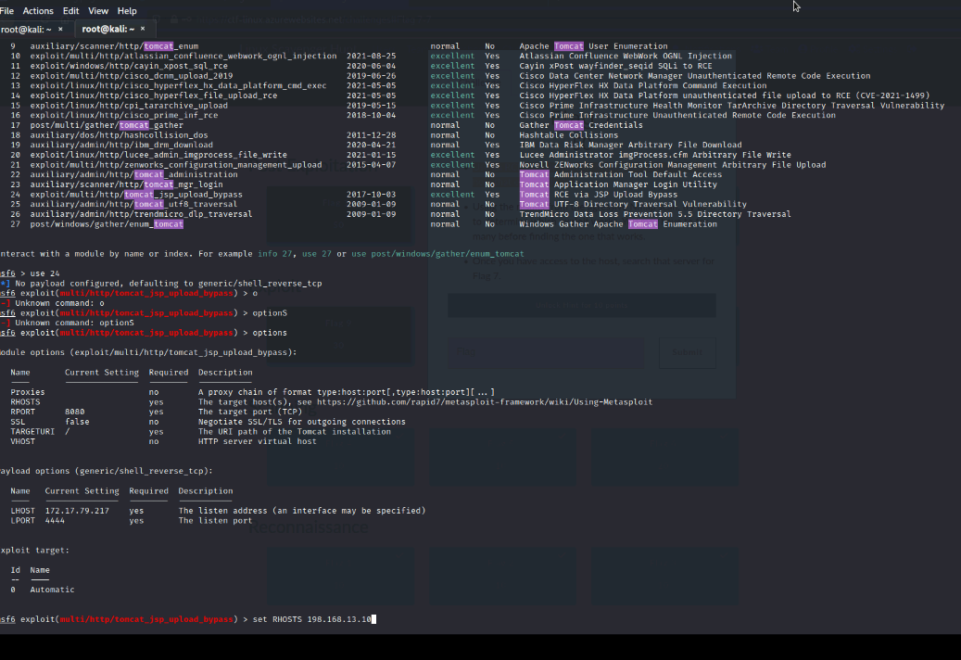
- Found Tomcat JSP exploit. HTTP bypass.
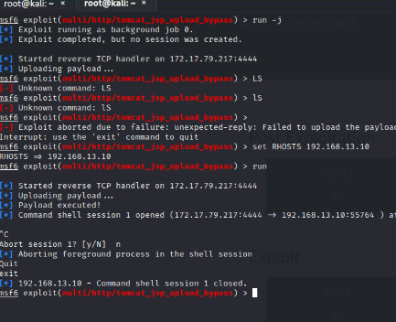

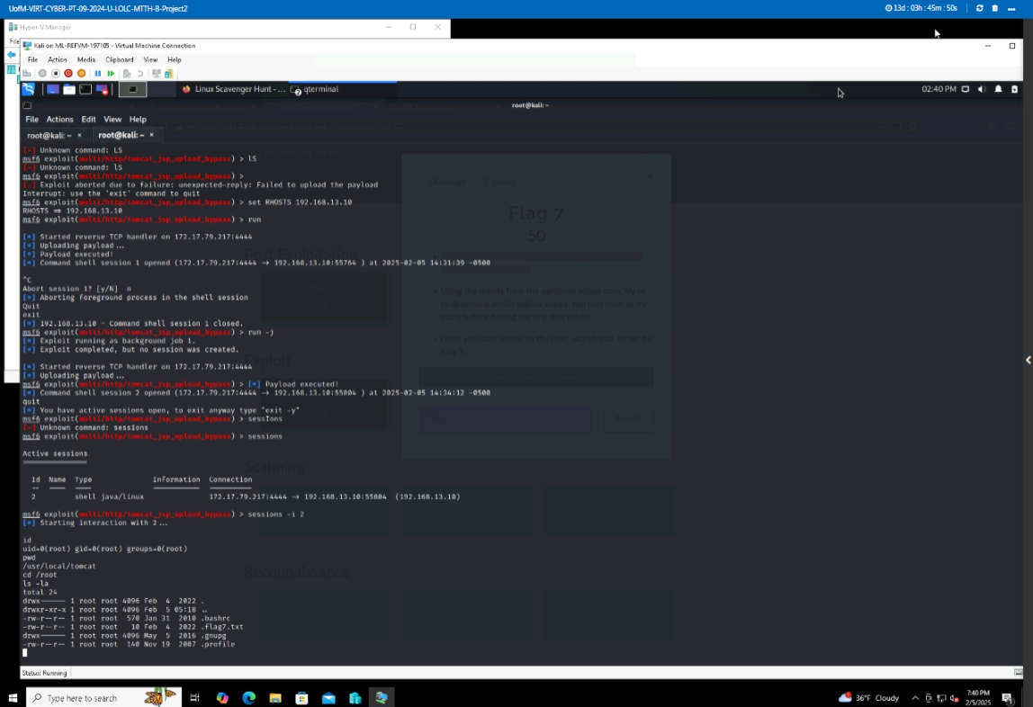

- Exploited a session became ROOT.

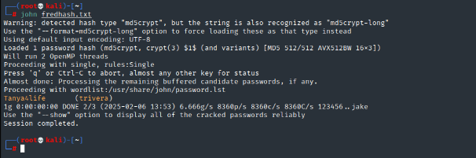

- URL:Github.comusercontent.com
- Found credentials on github site cracked password using the linux John

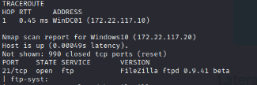

- Ran nmap -sV – sC 172.22.117.0/24 to scan the network for servers
that are running websites

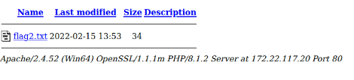
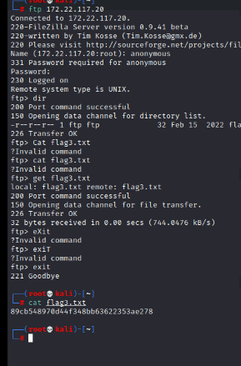

Access ftp 172.22.117.20 server using login credentials anonymous: without a password

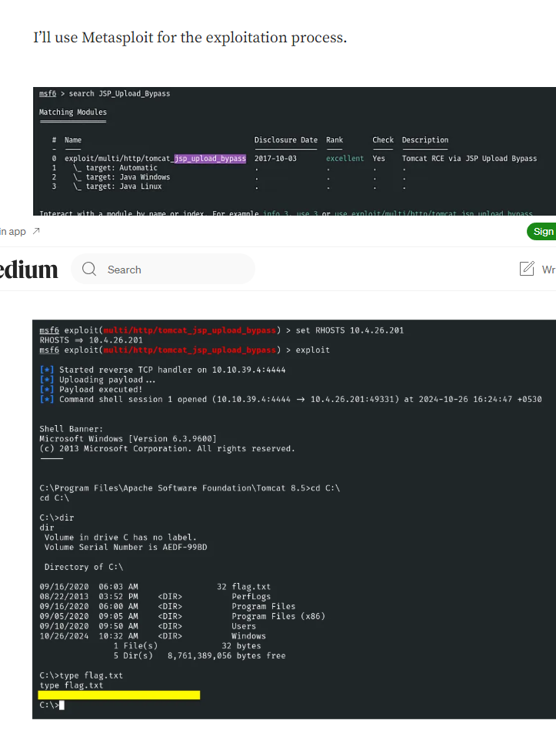

Executive Summary

I-Connect Solutions Inc. launched an external engagement against ReKall’s network(s). During the testing, we uncovered weaknesses and vulnerabilities throughout the network. OSINT (Open-Intelligence), port scanning, and enumeration services provided the data needed to infiltrate Rekall’s network. We identified weak password usage, system misconfigured and other vulnerabilities that could put Rekall at risk of unauthorized access or sensitive data being compromised. .

Summary Vulnerability Overview

Vulnerability | Severity
Executed xss reflected script against web application | Medium
SQL Injection payload | Critical
Command Injection web app | High
Poor Password polices | High
Admin credentials captured/Brute Force | Critical
Metasploit RCE vuns | Critical

The following summary tables represent an overview of the assessment findings for this penetration test:

Scan Type | Total
Hosts | 192.168.14.35/192.168.13.10
Ports | 80

Exploitation Risk | Total
Critical | 3
High | 2
Medium | 1
Low | 0

Vulnerability Findings

Vulnerability 1 | Findings
Title | Cross Site Scripting (xss) Exposure
Type (Web app / Linux OS / WIndows OS) | Web Application
Risk Rating | Medium
Description | Reflected Cross Site Scripting(xss) in Web Application login form allowed for unauthorize access.
Images | 
Affected Hosts | 192.168.14.35
Remediation | Input Validation, Fire Wall and System Updates

Vulnerability 2 | Findings
Title | Database Vulnerability
Type (Web app / Linux OS / WIndows OS) | Web Application
Risk Rating | Critical
Description | SQL Injection payload used to bypass website authentication process
Images | 
Affected Hosts | 192.168.14.35
Remediation | Employ strict Input Validation processes, Audit system continuously, Patch Management.

Vulnerability 3 | Findings
Title | Command Line Injection Vulnerability
Type (Web app / Linux OS / WIndows OS) | Web Application
Risk Rating | Critical
Description | Command Injection allows access to the O/S and able to execute various system commands.
Images | See Above
Affected Hosts | 192.168.14.35
Remediation | Input Validation, Patch Management,

Vulnerability 4 | Findings
Title | Password Guessing/Brute Force
Type (Web app / Linux OS / WIndows OS) | Web Application
Risk Rating | High
Description | Brute Force Attack User Credentials melina:melina
Images | 
Affected Hosts | 192.168.14.35 Login.PHP
Remediation | Input Validation, User Training, System Updates and Testing.

Vulnerability 5 | Findings
Title | Sensitive Data Exposure
Type (Web app / Linux OS / WIndows OS) | Windows Application
Risk Rating | Critical
Description | User Credentials found in the HTML source code.dougquaid:kuato
Images | 
Affected Hosts | 192.168.14.35 Login.PHP
Remediation | Input Validation, User Training, System Updates and Testing.

Vulnerability 6 | Findings
Title | Apache Remote Control Execution Vuns
Type (Web app / Linux OS / WIndows OS) | Linux OS.
Risk Rating | Critical
Description | Found open port Apache Tomcat server, lead to RCE and was able to exploit and gain to root access.
Images | 
Affected Hosts | 192.168.13.12
Remediation | Fire Wall protection, Patch Management, system monitoring and alerts.

Vulnerability 7 | Findings
Title
Type (Web app / Linux OS / WIndows OS) | Linux OS
Risk Rating | Critical
Description | Become Root via Metasploit RCE.
Images | 
Affected Hosts | 192.168.13.10
Remediation | Patch Management, System Alerts & Checks

Add any additional vulnerabilities below.

